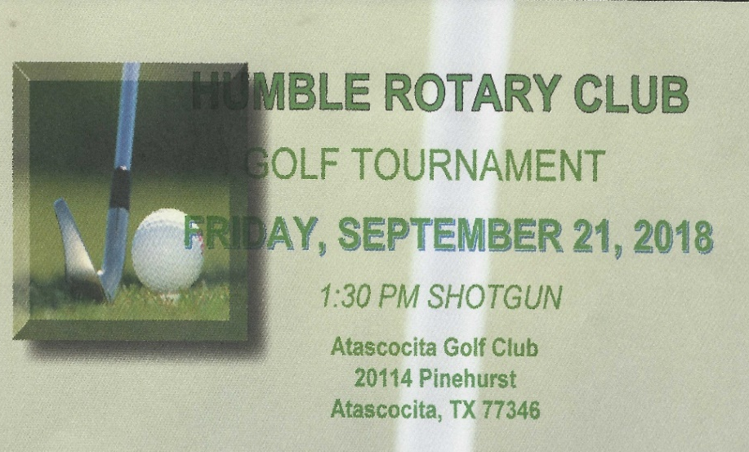

HUMBLE ROTARY 2018 SPONSORSHIPS
(*See reverse side for level benefit details)
SPONSORSHIP LEVEL GOLF TOURNAMENT FESTIVAL BOTH /SPLIT*

______$ 5,000 _______ _______ _______

______ $ 3,000 _______ _______ _______

______ $ 2,500 _______ _______ _______

______ $ 1,500 _______ _______ _______

______ $ 1,000 _______ _______ _______

______ $ 500 _______ _______ X

______$ 100 _______ _______ X

Name as it will appear in print: ______________________________________________________

Best telephone number email address

Signature: __________________________________________________Date__________________

Humble Intercontinental Rotary Foundation, Inc. 501 c (3) #76-0579934
Invoice and marketing information will follow.

RETURN FORM TO: DEBORAH ROSE MILLER / deborahrose@sbcglobal.net

